**Leader Overview**

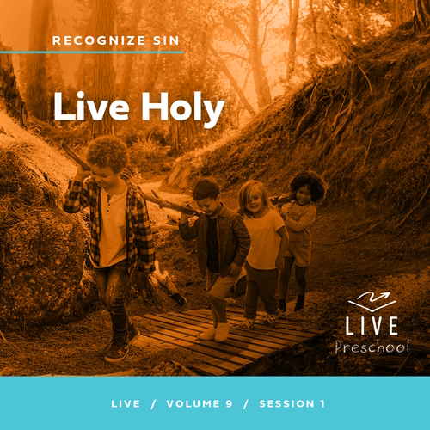

**Volume Overview**

**Recognize Sin**

*The Bible has a lot to say about sin and forgiveness. It acknowledges the deep brokenness of this world and our individual life. It is only by understanding the depth of human sin that we can understand the remarkable work of God’s forgiveness. Because of His forgiveness, we escape the eternal consequence of our sin and can rightly respond to the call to live a holy life. We learn to receive forgiveness, put off sin, and show forgiveness to those who have sinned against us. We learn to pursue holiness in the midst of the world’s brokenness.*

**Session Overview**

**Live Holy**

*In this* **Live** *session, preschoolers will discover Jesus wants to clean their heart of sin and help them leave sin behind. Through the story of Jesus clearing the temple of improper business, kids will see that Jesus helps them lead a holy life.*

**Bible Lesson**

Jesus Clears the Temple

[Mark 11:15–19](https://ref.ly/logosref/Bible.Mk11.15-19)

**Faith Fact**

I will leave my sin behind.

**Faith Verse**

[2 Corinthians 5:17](https://ref.ly/logosref/Bible.2Co5.17) (NLT)

Anyone who belongs to Christ has become a new person. The old life is gone; a new life has begun!

**Preparing for the Session**

**Leader Preparation Time: 20–25 Minutes**

|  |
| --- |
| ***You Will Need***  ***Preservice Activities***  *• Toys*  *• Small stuffed animal*  *• Small doughnuts, one per kid plus leader*  *• Chocolate chips or similar small snack to fill doughnut hole*  *• Plates or napkins, one per kid*  ***Large Group***  *• Bible*  *• Worship songs (Song suggestions: “Never Be Shaken” by Shout Praises Kids; “King of Me” by Rend Co. Kids; “Never Be the Same” by Fellowship Worship)*  *• For groups not using a phone or tablet only, add:*  *• Projector or TV*  *• Laptop*  *•* ***Faith Fact Sound*** *video (bell ringing)*  *•* ***Faith Fact Slide***  *•* ***Faith Verse Slide***  *•* ***Faith Verse Video***  *•* ***Bible Lesson Video A***  *•* ***Bible Lesson Video B***  ***Small Group***  *•* ***Small Group Group Connection Page****, one per group*  *• Scissors*  *•* ***Small Group Activity Page****, one per kid*  *• Pencils or pens, one per kid*  *•* ***Small Group Feet-to-Floor Page****, five per group*  *• Plastic bottles, ten*  *• Tape*  *• Scissors*  *• Small soft ball*  *• Floor-safe tape (masking tape or painter’s tape)*  *• Flashlight*  *To access session content and videos from a computer, visit:* [***BibleEngagementProject.com/downloads***](https://bibleengagementproject.com/downloads) |
| ***Getting Ready***  ***Preservice Activities***  *• Set out toys and snacks.*  ***Large Group***  *• Download videos and slides if needed.*  *• Select worship song(s) and have them ready to play.*  ***Small Group***  *• Print the* ***Small Group Group Connection Page****, one per group.*  *• Cut apart the pictures.*  *• Print copies of the* ***Small Group Activity Page****, one per kid*  *• Print the* ***Small Group Feet-to-Floor Page****, five per group.*  *• Cut the page into strips.*  *• Wrap the bottles with these strips and tape in place.*  *• Create a starting line on the floor with the floor-safe tape.*  ***First time leading* Live *for Preschool? Check out the*** [**Facilitator Guide**](https://0b769b0ed3569ef9d18b-f88d8272f61086866d50d048b43ef630.ssl.cf2.rackcdn.com/sites/biblengagementproject/Listen_Facilitator_Guide.pdf)**.** |

**Preservice Activities**

*See what’s needed at the beginning of the session.*

|  |
| --- |
| ***You Will Need***  *• Small stuffed animal*  *• Small doughnuts, one per kid plus leader*  *• Chocolate chips or similar small snack to fill doughnut hole*  *• Plates or napkins, one per kid*  *No prep needed for this activity.* |

**Bible Story Warm-Up**

Most kids have something that’s very special to them. For example, you may have a favorite stuffed animal *(hold up the stuffed animal),* pillow, blanket, or some other thing that you have loved for a long time. Let’s take turns passing this one around. When you have it, tell us what your favorite thing is.

• *Pass the stuffed animal around the group.*

Now, imagine if you were going on a trip, but you forgot to pack your favorite thing. How would it make you feel if you forgot to take it with you?

Have you ever forgotten something special and left it behind when you were away from home? What happened?

Have you ever forgotten something like your lunch or a jacket when you went to school or to church?

Leaving behind special things can make us sad. Sometimes it’s okay to leave things behind or outgrow them. Think of your favorite shoes. They can’t go with you forever because your feet will get bigger. Maybe you have an awesome bike, but one day you’ll get taller and need a bigger one. What are some other things that it’s okay to leave behind as you grow up? *(Allow responses.)*

Those were some great answers! In today’s Bible story, we’ll learn about something that Jesus wants us to leave behind. Be sure to keep your ears open and eyes focused as we have fun learning about that together today.

**Snack**

**Mini Doughnuts and Chocolate Chips**

Today, we have an awesome snack! Before you eat it, I want to tell you about something. We’ll learn what it means to live holy. Do you think that’s like having a hole in your jeans, in your sock, or even in a doughnut like this *(hold up a doughnut)*? *(Group response)*

The word *holy* doesn’t mean that. Being holy means that you’re special to God and that He has special plans for you. God’s plan is for you to do good things and not bad things, called sin.

Think about this doughnut. The plan for a doughnut is to be eaten because it’s yummy food, right? The plan is not to throw like a ball. If we threw the doughnut, it would probably break and get dirty. Being holy is a little like that. We need to follow God’s plan and fill our life with things He says are good *(fill the doughnut with chocolate chips)*. Each of you is special to God; you’re holy. So, let’s do good things as His holy kids. Who would like to make a snack like this as a reminder to live holy? *(Group response)*

• *Hand out snacks and let kids fill the doughnut hole.*

Before we eat our snack, let’s pray and thank God for helping us to choose to follow Him. Everyone, close your eyes and bow your heads.

|  |
| --- |
| *Dear God, thank You for loving us and having a good plan for us. Thank You for making us special. Please help us to follow You so that we can live holy. We love You. Amen.* |

Enjoy your snack! I have a great time planned for us all together, and I can’t wait to keep learning with you.

**Free Play**

*Any extra time can be spent playing with toys.*

**Transition**

*A few minutes before service begins have kids make their way to the large group area and sit in their designated areas.*

**Large Group**

**25 Minutes**

*See what’s needed at the beginning of the session.*

**Introduction**

Hi, friends! My name is _________. It makes me smile to see you here today! Point to yourself and say, “I’m glad I’m here!” *(Group response)* Now, point to a friend and say, “I’m glad you’re here!” *(Group response)* We’ll have so much fun learning from God’s Word together. *(Hold up the Bible.)*

Today, we’ll talk about Jesus visiting the temple, which was like a church. When He got there, He saw something He didn’t like. He knew the temple was a special place to worship God. Instead, there were some people using God’s temple like a store. Jesus said those people had to leave.

**Faith Fact**

Jesus wants to do something like that in our heart, too. He wants our heart and life to be clean from any wrong things we do. Those wrong things are called *sin*. He gives us the power to leave our sin behind so we can live a holy life. That’s our Faith Fact today. **I will leave my sin behind.**

• *Show the* ***Faith Fact Slide.***

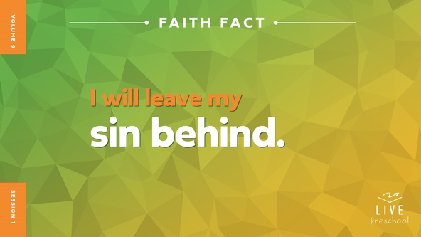

Let’s say our Faith Fact together. **I will leave my sin behind.** Let’s pretend we’re throwing something over our shoulder like we’re leaving that sin behind. **I will leave my sin behind.** *(Group response)* Awesome! Let’s say it one more time as loudly as we can for everyone to hear. **I will leave my sin behind.**

**Bible Time**

One of the ways God helps us leave sin behind is by showing us His truth in the Bible. We’ve got someone special to help us learn from God’s Word. Let’s see what Lizzy is doing.

• *Play* ***Bible Lesson Video A****.*

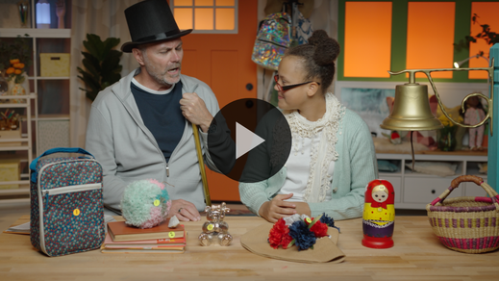

I’m glad Grandpa and Lizzy gave us a little time to think. Let’s worship now. Then, I’ll ask you what you think will happen next in our Bible story.

**Worship**

Today’s Bible story reminds us that worship is very important to God. He wants us to come together to worship Him just like we’re doing right now. We get to tell Him how much we love Him. Let’s focus our heart and mind on how good God is to us.

**Praise**

Who wants to thank God for forgiving our sins? Touch your toes down low. *(Group response)*

Are you glad we can trust God? Clap your hands two times. *(Group response)*

Who is ready to worship God now? Wave your hands up high. *(Group response)*

**Sing**

God loves it when we praise Him together. Let’s worship God by singing to Him.

• *Lead the kids in singing one or two songs. See song suggestions at the beginning of the session.*

**Prayer**

I love worshipping with you! God loves to hear our worship, and He loves to hear our prayers. Let’s all bow our heads and talk to God.

|  |
| --- |
| *Dear God, You love us more than we can even really understand. Thank You for Your great love. You are stronger than anything in this world. We want to say yes to living holy. Help us to leave our sin behind. Amen.* |

**Bible Time cont’d**

Grandpa and Lizzy will be back soon. Let’s think about the answer to what happens next in our Bible story. Put on your thinking cap *(demonstrate).* Did Jesus let people keep doing the wrong things at the temple? *(Point to “green stoplight” graphic.)* Or did Jesus tell the people to stop what they were doing and get rid of the sinful things at the temple? *(Point to “red stoplight” graphic.)*

• *Have kids do the following actions.*

If you think Jesus went along with the wrong things and pretended not to see them, cover your eyes. If you think Jesus got rid of the sinful things, wave your finger back and forth like you’re saying, “No, no, no.” Choose your answer.

• *Pause while kids respond.*

Let’s find out if you’re right! Let’s check back in with Lizzy and Grandpa.

• *Play* ***Bible Lesson Video B.***

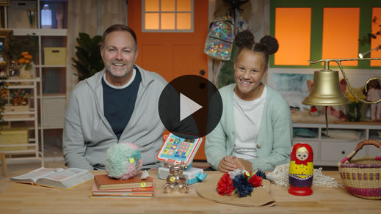

**Response Time**

*Play a worship song quietly.*

Let’s respond to what we’ve learned from God’s Word today. We have all made wrong choices that hurt us or hurt the people around us. Jesus says we don’t have to keep making wrong choices. He helps us leave sin behind like our Faith Fact says. Let’s pray and ask Him to do that today.

• *Have the kids repeat phrases of the prayer after you.*

|  |
| --- |
| *Dear Jesus, You know I have done wrong things and sinned. You want to help me make good choices. Please help me to leave sin behind. I want to fill my life with You because You love me so much. Thank You for Your forgiveness. Amen.* |

**Faith Verse**

We can fill up our heart and mind with God’s words by learning verses from the Bible. Let’s say our Faith Verse and do the actions together.

[2 Corinthians 5:17](https://ref.ly/logosref/Bible.2Co5.17) (NLT)

Anyone who belongs to Christ has become a new person. The old life is gone; a new life has begun!

• *Show the* ***Faith Verse Video****.*

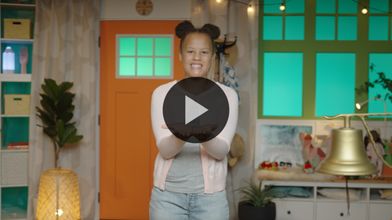

**2 Corinthians** *(hands at waist, spread apart, palms up and out)*

**5:** *(hands together like a clap)*

**17** *(hands opened to “book”)*

**Anyone who** *(point to other people)*

**belongs to Christ** *(do sign language for Jesus, middle finger to opposite palm, with each hand)*

**has become a new person.** *(spin around)*

**The old life is gone;** *(crouch low to ground)*

**a new life has begun!** *(jump with arms and feet spread wide)*

**Closing**

Did you learn more about God from the Bible today? *(Group response)* I had a great day worshipping and praying to God with you. Our Faith Verse will help us to remember that we are a new person when we leave sin behind with Jesus’ help.

• *Play the* ***Faith Fact Sound*** *video (bell ringing).*

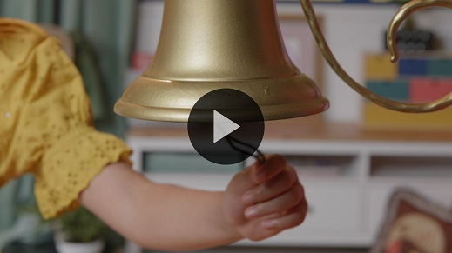

That sound means it’s time to say our Faith Fact together one more time. **I will leave my sin behind**.

• *Show the* ***Faith Fact Slide.***



Let’s say our Faith Fact while we pretend to smell the smelliest sin we can imagine. *(Hold nose and waft hand.)* **I will leave my sin behind**. Let’s say it one last time in your happiest voice because that sin is behind you. **I will leave my sin behind.**

**Dismissal to Small Groups**

Great job! Now it’s time to spend time in our very special small groups. Let’s keep learning about leaving our sin behind!

• *Dismiss the kids by groups.*

|  |
| --- |
| ***Leader Tip:*** *This can be done by assigning color teams or by age groups. Note that some young preschoolers may not know their age. Using a colored sticker, jersey, or wristband will help separate the kids and help identify their small groups.* |

**Small Group**

**25 Minutes**

*See supplies and prep instructions at beginning of session or in each activity below.*

|  |
| --- |
| ***Leader Tip:*** *Small groups can alternate to each circle, or all groups can do each activity at the same time. If you choose to alternate, you will need at least one leader per circle.* |

**Circle 1**

**Group Connection**

**Thumbs Up, Thumbs Down**

|  |
| --- |
| ***You Will Need***  *•* ***Small Group Group Connection Page****, one per group*  *• Scissors*  ***Getting Ready***  *• Print the* ***Small Group Group Connection Page****, one per group.*  *• Cut apart the pictures.* |

If you’re ready to play a game, give me two thumbs up! *(Group response)* Awesome! It looks like everyone wants to play a game. What’s even better is you did one of the moves for it when you showed me a thumbs up. We’ve learned that Jesus wants us to live holy. One of the ways we do that is by making good choices and following after the things God wants us to do.

I’ll hand out these pictures. Some of the pictures will be something good we should do. We’ll give those pictures a thumbs up. Some of the pictures will show things we shouldn’t do because they make Jesus sad. We’ll give those pictures a thumbs down. When you get your picture, don’t show it to anyone. Think about whether it shows something we should do or should not do.

• *Hand out the pictures to the kids.*

One at a time, you’ll take turns holding up your pictures. Together we’ll decide if that’s a thumbs up or thumbs down thing to do.

• *Lead kids through the activity, allowing them to show the pictures and choose thumbs up or thumbs down.*

• *During the activity, interrupt and practice the Faith Fact:* **I will leave my sin behind.**

• *Play the* ***Faith Fact Sound*** *video****.*** *Review the Faith Fact even if you can’t play the sound.*



That was amazing! Give yourselves two thumbs up! It’s easy to see that you know what things are good or bad. That’s how we can live what our Faith Fact says. Let’s say it together one time before we go to our next activity. How should we say it this time? I know! Two thumbs up reminds me of winning, so let’s say it together as excited as we can. Ready? **I will leave my sin behind.** Fantastic!

**Circle 2**

**Activity Page Time**

**New Me Maze**

|  |
| --- |
| ***You Will Need***  *•* ***Small Group Activity Page****, one per kid*  *• Pencils or pens, one per kid*  ***Getting Ready***  *• Print copies of the* ***Small Group Activity Page****, one per kid.* |

The Bible is filled with amazing truths and promises. In fact, our Faith Verse is a powerful promise of what happens when we choose to follow Jesus and not sin. Let’s say it together.

• *Lead kids through the Faith Verse using the actions.*

[2 Corinthians 5:17](https://ref.ly/logosref/Bible.2Co5.17) (NLT)

Anyone who belongs to Christ has become a new person. The old life is gone; a new life has begun!

**2 Corinthians** *(hands at waist, spread apart, palms up and out)*

**5:** *(hands together like a clap)*

**17** *(hands opened to “book”)*

**Anyone who** *(point to other people)*

**belongs to Christ** *(do sign language for Jesus, middle finger to opposite palm, with each hand)*

**has become a new person.** *(spin around)*

**The old life is gone;** *(crouch low to ground)*

**a new life has begun!** *(jump with arms and feet spread wide)*

When Jesus forgives us, He makes us like new. He gives us new plans for our life. Part of that plan is to get sin out of our life. On our Activity Page, you will see there are two hearts—a clean one and a sin-filled one. Your job is to find the way through the maze to the clean heart on the other side. Along the way you’ll see a few pictures. They are clues to show if you are on the right path or not. Let’s see who can make it through the maze.

• *Hand out a copy of the* ***Small Group Activity Page*** *and a pencil to each kid. Give kids time to complete the activity.*

**Circle 3**

**Feet-to-Floor Game Time**

**Knock Out Sin**

|  |
| --- |
| ***You Will Need***  *•* ***Small Group Feet-to-Floor Page****, five per group*  *• Plastic bottles, ten*  *• Tape*  *• Scissors*  *• Small soft ball*  *• Floor-safe tape (masking tape or painter’s tape)*  ***Getting Ready***  *• Print the* ***Small Group Feet-to-Floor Page****, five per group.*  *• Cut the page into strips.*  *• Wrap the bottles with these strips and tape in place.*  *• Create a starting line on the floor with the floor-safe tape.* |

Today, we’ve learned a very important Faith Fact. Can anybody tell me what it is? *(Allow responses.)* That’s right. **I will leave my sin behind.** I want each of you to clean out sin in your life and follow Jesus. We clean out the sin when we ask Jesus to forgive our sins.

Let’s play a fun game to help us remember to knock out sin. These bottles represent sin that we need to get out of our life. *(Point to the bottles.)* We’ll take turns rolling a ball toward these bottles to see how many we can knock down. When we get them all knocked down, let’s shout our Faith Fact together.

• *Allow kids to take turns bowling until all the bottles are knocked down.*

• *Say the Faith Fact together. Play again if you have time.*

Wow! You’re awesome at bowling and knocking down sin! Let’s all remember to do that in our lives, too!

**Circle 4**

**Hands-On Learning**

**Face the Son**

|  |
| --- |
| ***You Will Need***  *• Flashlight*  *No prep needed for this activity.* |

Our Faith Fact reminds us that we can leave our sin behind and live holy. In our Bible story, we learned that Jesus was upset because people were treating God’s temple like it wasn’t holy. God’s temple was a special, holy place. Each of you are holy and special to God, too. It’s important for us to leave our sins behind and follow His plan.

It’s kind of like this flashlight *(hold up the flashlight)*. Let’s pretend the light that it shines represents God. Now, I need a volunteer to help me.

• *Have a kid stand in front of the group, facing to one side. Then, stand a few feet behind the kid.*

• *Shine the flashlight at the kid from above, casting a shadow in front of the kid.*

When I shine the light, can you see a shadow? *(Group response)* Let’s pretend the shadow represents our sin. With our volunteer’s body in front of the light, we can see the shadow in front of them. If the volunteer waves their hands, we see that their shadow copies them. In this example, the person can see the sin they have done, right? We see the shadow, and the shadow represents sin. Let’s try something different.

• *Have a different kid face you and the flashlight.*

• *Shine the flashlight at the kid, avoiding their eyes.*

This time, when I shine the flashlight at our volunteer, can you see the shadow in front of them anymore? *(Group response)* No, it’s behind them. This time the volunteer can only see the light shining at them. The same is true with our sin. When we choose to focus on God, represented by the light, He will forgive our sins and will put them behind us like the shadow. It’s like we can’t see our sin anymore. Keeping our eyes on God is how we leave our sin behind. Does anyone else want to make a shadow? *(Allow responses.)*

• *Allow kids to take turns making a shadow and then facing the flashlight.*

**Dismissal**

• *Play the* ***Faith Fact Sound*** *video (bell ringing).*



• *Show the* ***Faith Fact Slide.***



Wow! Today has been so much fun. We got to worship, play, and learn more about God’s Word together. Before we go, can you help me say our Faith Fact one more time? *(Group response)* Great! **I will leave my sin behind.** Great job! See you next time.

• *Send home the* ***Small Group******Activity Page*** *with each kid.*

• *Remind parents that there are* ***Family Devotions*** *available on the app to do with their kid.*

• *Tell everyone the date and time for the next session.*